Laravel Lab 1

Git <http://git-scm.com>

* 1. Download from <http://git-scm.com/downloads>
  2. Created by Linus Torvalds
  3. The creators’ purpose of the software was to create their own open source tool for version control that focused on speed, a simple design, strong support for non-linear development, being fully distributed, and able to handle large projects like the Linux kernel efficiently.
  4. From my perspective, the purpose of this software is to allow for multiple developers to work on a piece of software and to have the ability to recall a previous version later as well as store the software in a centralized place.
  5. The latest version is v2.3.1
  6. Fixes since last version include:
     1. Fixed the interactive show list interface that used to show even when nothing was listed
     2. "git apply --whitespace=fix" used to under-allocate the memory
     3. “git log –help” used to show a list of irrelevant options
     4. “git commit” used to show a non-existent author name
     5. A broken .idx file prevented fetching of a good copy from the server
     6. Incorrect documentation stated that only Copy and Rename can follow the score number in the output
     7. Fix misspelled conditional that was always true
     8. When file was empty, could not read files from .git/ directory
     9. Rewrote document for “git push”
     10. After failing password-less authentication, libcURL did not fall back to Basic Authentication
     11. Several broken patches would occur from “git format-patch”
     12. “git rerere” did not correctly signal errors
     13. “git blame HEAD – missing” did not correctly say HEAD
  7. Alternative to Git are: Subversion and Mercurial
  8. YouTube tutorial found at <https://www.youtube.com/watch?v=Kp5BSBoOw8k>
  9. Another tutorial found at <http://www.sitepoint.com/git-for-beginners/>
  10. 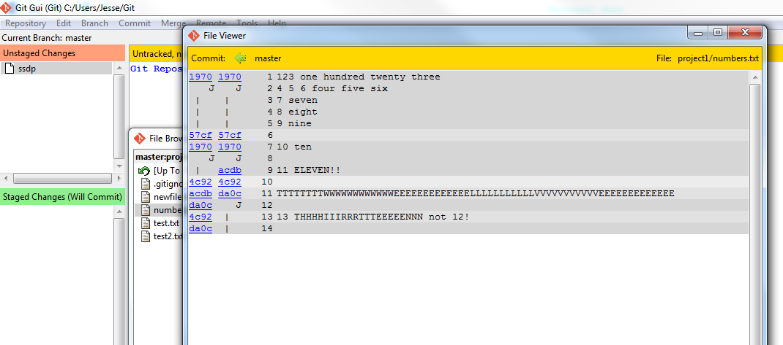

1. PHPStorm <https://www.jetbrains.com/phpstorm/>
   1. Download from <https://www.jetbrains.com/phpstorm/download/>
   2. Created by JetBrains
   3. The creators’ purpose of the software is to enjoy productive PHP and web development and to take advantage of deep code understanding, top-notch coding assistance, and support for all major tools and frameworks.
   4. From my perspective, the purpose of this software is to create a rich IDE that allows for coding on all languages, frameworks and architectures.
   5. The latest version is v8.0.3
   6. Updates since last version include:
      1. Support for Laravel Blade templates
      2. PHP language support for language injections
      3. Full support for PHP 5.6
      4. Support for PSRF-0/PSR-4 standards on namespace roots
      5. Support for Blade, Wordpress, BDD for PHP
      6. Remote PHP interpreters
      7. Support for Advanced angularJS
      8. Overall IDE improvements for ease of use
   7. Alternative to PHPStorm are: Eclipse and SublimeText
   8. YouTube tutorial found at <https://www.youtube.com/playlist?list=PLQ176FUIyIUbfeFz-2EbDzwExRlD0Bc-w>
   9. Another tutorial found at <https://www.jetbrains.com/phpstorm/documentation/>
   10. 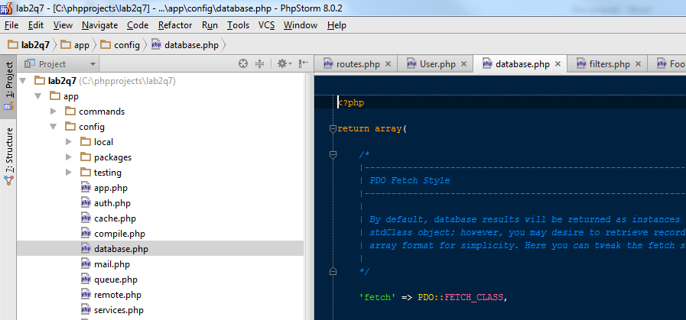
2. GitHub <https://github.com/>
   1. Download from <https://windows.github.com/> or <https://mac.github.com/>
   2. Created by Preston-Werner, Chris Wanstrath, PJ Hyett, Scott Chaco
   3. The creators’ purpose of the software was to simplify code sharing.
   4. From my perspective, the purpose of this software is to provide an online version control system based on git where users can share and work on code across any system, as well as being a business to make money.
   5. The latest version is v2.9.1
   6. Updates include:
      1. Fixed tracked repositories that weren’t loading correctly.
   7. Alternative to GitHub are: SourceForge and Bitbucket
   8. Youtube tutorial found at <https://www.youtube.com/watch?v=0fKg7e37bQE>
   9. Another tutorial found at <https://guides.github.com/activities/hello-world/>
   10. 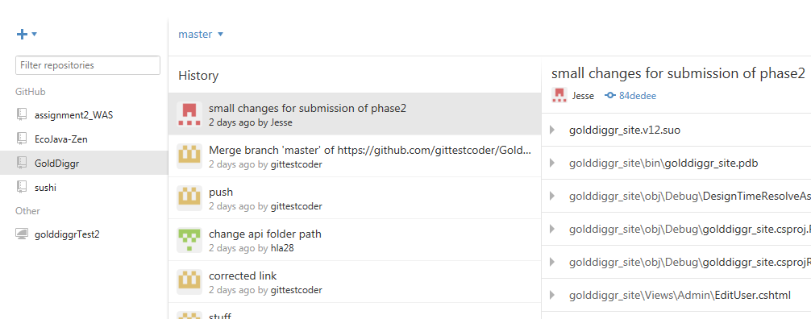
3. Apache2.4 <http://httpd.apache.org/>
   1. Download from <http://httpd.apache.org/download.cgi>
   2. Created by the Apache Software Foundation
   3. The creators’ purpose of the software was aimed at creating a robust, commercial-grade, featureful, and freely-available source code implementation of an HTTP (Web) server.
   4. From my perspective, the purpose of this software is to provide an open source server that is an alternative to Windows IIS.
   5. The latest version is v2.4.12
   6. Updates include:
      1. Multiple updates at <http://apache.sunsite.ualberta.ca//httpd/CHANGES_2.4.12>
   7. Alternative to Apache2.4 are: Cherokee and Microsoft IIS
   8. Youtube tutorial found at <https://www.youtube.com/watch?v=xCJkMIYwjp8>
   9. Another tutorial found at <http://httpd.apache.org/docs/2.0/misc/tutorials.html>
   10. 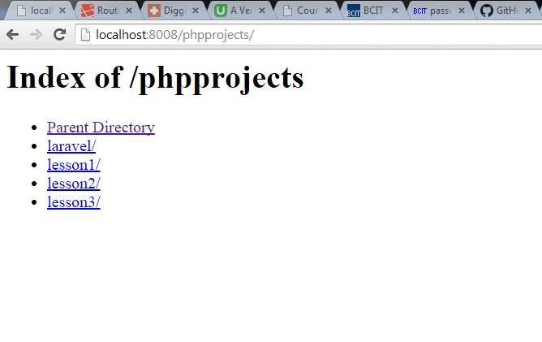
4. PHP5.6 <http://php.net>
   1. Download from <http://php.net/downloads.php>
   2. Created by [Rasmus Lerdorf](http://en.wikipedia.org/wiki/Rasmus_Lerdorf)
   3. The creator’s purpose of the software was to create a popular, general-purpose scripting language that is especially suited to web development. It was intended to be fast, flexible, and pragmatic to power everything from blogs to the most popular websites in the world.
   4. From my perspective, the purpose of this software is to provide a powerful and flexible server side scripting language to offer more adaptability to handling server client requests on the server.
   5. The latest version is v5.6.6
   6. Updates include:
      1. Multiple updates at <http://php.net/ChangeLog-5.php#5.6.6>
   7. Alternative to PHP5.6 are: Ruby, Python, ASP
   8. Youtube tutorial found at <https://www.youtube.com/watch?v=7UMNz5T-0VQ>
   9. Another tutorial found at <http://www.w3schools.com/php/>
   10. 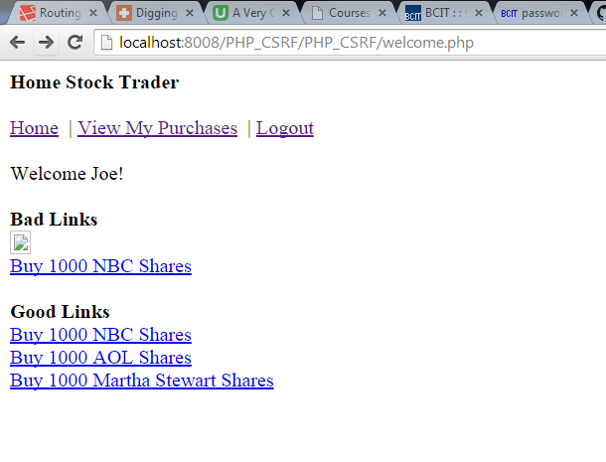
5. XDebug <http://xdebug.org>
   1. Download from <http://xdebug.org/download.php>
   2. Created by [XDebug,](http://en.wikipedia.org/wiki/Rasmus_Lerdorf) open-source
   3. The creators’ purpose of the software was to create a debugger whose basic functions include the display of stack traces on error conditions, maximum nesting level protection and time tracking.
   4. From my perspective, the purpose of this software is to provide a helpful plugin to aid in the debugging of web apps that is integrated with the browser and the IDE.
   5. The latest version is v2.3.1
   6. Updates include:
      1. addresses a crash and broken triggers for profiling and tracing.
   7. Alternative to XDebug are: SQLite, PostgreSQL, MongoDB
   8. Youtube tutorial found at <https://www.youtube.com/watch?v=yPu6qV5byu4>
   9. Another tutorial found at <http://www.mysqltutorial.org/>
6. MySQL <http://www.mysql.com>
   1. Download from <http://dev.mysql.com/downloads/>
   2. Created by  MySQL AB, founded by David Axmark, Allan Larsson and Michael "Monty" Widenius
   3. The creators’ purpose of the software was to create the world’s most popular open source database.
   4. From my perspective, the purpose of this software is to offer an open source alternative to Microsoft’s SQL that is lightweight, flexible and powerful.
   5. The latest version is v5.6.23 (Community Edition)
   6. Updates include:
      1. Multiple updates at <http://dev.mysql.com/doc/relnotes/mysql/5.6/en/news-5-6-23.html>
   7. Alternative to XDebug are: Webgrind and WPN-XM
   8. Youtube tutorial found at <https://www.youtube.com/watch?v=9bV0_gk0fkk>
   9. Another tutorial found at <http://webcheatsheet.com/php/debug_php_with_xdebug.php>
   10. 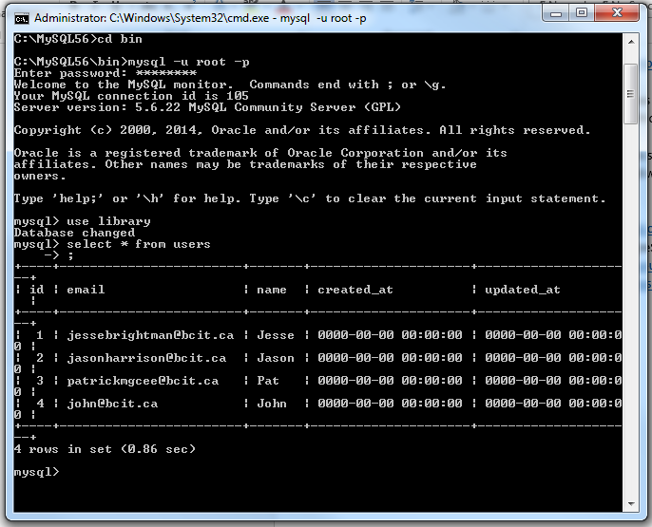
7. cURL <http://curl.haxx.se>
   1. Download from <http://curl.haxx.se/download.html>
   2. Created by  curl.haxx.se, open-source
   3. The creators’ purpose of the software was to create a command line tool and library for transferring data with URL syntax, supporting DICT, FILE, FTP, FTPS, Gopher, HTTP, HTTPS, IMAP, IMAPS, LDAP, LDAPS, POP3, POP3S, RTMP, RTSP, SCP, SFTP, SMB, SMTP, SMTPS, Telnet and TFTP. curl supports SSL certificates, HTTP POST, HTTP PUT, FTP uploading, HTTP form based upload, proxies, HTTP/2, cookies, user+password authentication (Basic, Plain, Digest, CRAM-MD5, NTLM, Negotiate and Kerberos), file transfer resume, proxy tunneling and more.
   4. From my perspective, the purpose of this software is to offer an open source tool that helps pass data from one system to another in the background(ie not in a browser) and that allows automatic updates to applications as well as making sure dependencies are checked.
   5. The latest version is v7.41.0
   6. Updates include:
      1. Multiple updates at <http://curl.haxx.se/changes.html>
   7. Alternative to XDebug are: Wget and Transmit
   8. Youtube tutorial found at <https://www.youtube.com/watch?v=XcgQUsorF_8>
   9. Another tutorial found at <http://code.tutsplus.com/tutorials/techniques-for-mastering-curl--net-8470>
8. Composer <https://getcomposer.org>
   1. Download from <https://getcomposer.org/download/>
   2. Created by [Nils Adermann](http://naderman.de/), [Jordi Boggiano](http://nelm.io/jordi), and open-source contributors
   3. The creators’ purpose of the software was to create a tool for dependency management in PHP. It allows you to declare the dependent libraries your project needs and it will install them in your project for you.
   4. From my perspective, the purpose of this software is to offer an open source solution that manages the library dependencies that you need in each project. By declaring a library as required, Composer will automatically find out which versions you need, if those libraries depend on something else, and download and install them into your project.
   5. The latest version is v1.0.0-alpha9
   6. Updates include:
      1. Not available
   7. Alternative to XDebug are: Maven and Nanny
   8. Youtube tutorial found at <https://www.youtube.com/watch?v=QOldVDVYnAE>
   9. Another tutorial found at <http://code.tutsplus.com/tutorials/easy-package-management-with-composer--net-25530>
9. Swiftmailer <http://swiftmailer.org>
   1. Download from <http://swiftmailer.org/download>
   2. Created by Chris Corbyn, open source
   3. The creators’ purpose of the software was to create a component-based library for sending e-mails from PHP applications.
   4. From my perspective, the purpose of this software is to offer an open source email library that is easily added to php projects and that is flexible for users to integrate.
   5. The latest version is v5.3.1
   6. Updates include:
      1. Multiple updates at <http://laravel.com/docs/5.0/releases>
   7. Alternative to Swiftmailer are: CodeIgniter and Symfony2
   8. Youtube tutorial found at <https://www.youtube.com/playlist?list=PL09BB956FCFB5C5FD>
   9. Another tutorial found at <http://code.tutsplus.com/tutorials/building-web-applications-from-scratch-with-laravel--net-25517>
10. Laravel http://laravel.com
    1. Download from <https://github.com/laravel/laravel/archive/v4.2.11.zip>
    2. Created by Taylor Otwell, open source
    3. The creators’ purpose of the software was to create a beautiful and revolutionary php framework that allows for rapid development of web applications.
    4. From my perspective, the purpose of this software is to offer an open source web framework that allows developers to easily and quickly create an application through laravel’s use of intregrated framework, dependency management, and web serving service.
    5. The latest version is v5
    6. Updates include:
       1. fix for a regression that was introduced in 5.2.2
    7. Alternative to Swiftmailer are: PHPMailer and Swift
    8. Youtube tutorial found at <https://www.youtube.com/playlist?list=PLtkQ4qXd21-aHbhDWBazxZjtBwUhfqIII>
    9. Another tutorial found at <http://www.sitepoint.com/sending-email-with-swift-mailer/>